LAWYER WEBSITE

“LAW NETWORK”

**PROJECT:** Lawyer Website

**Group Members:-**

|  |  |
| --- | --- |
| **GROUP MEMBERS** | **ENROLMENT NO.** |
| Asma Atique | STUDENT1353632 |
| Mahnoor Tariq | STUDENT1349179 |

**FACULTY :** HAFSA KHAN

**BATCH CODE :** 2111G2

**CURRICULUM :** 7062

**SEMESTER :** DISM



CHAPTER: 01

HOME PAGE

This is the Home Page.

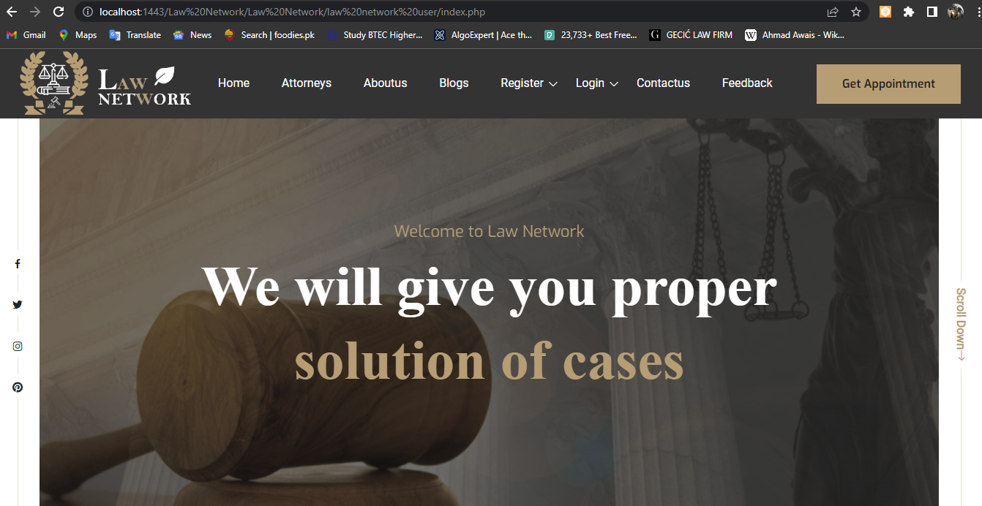

This is the Footer of our web.

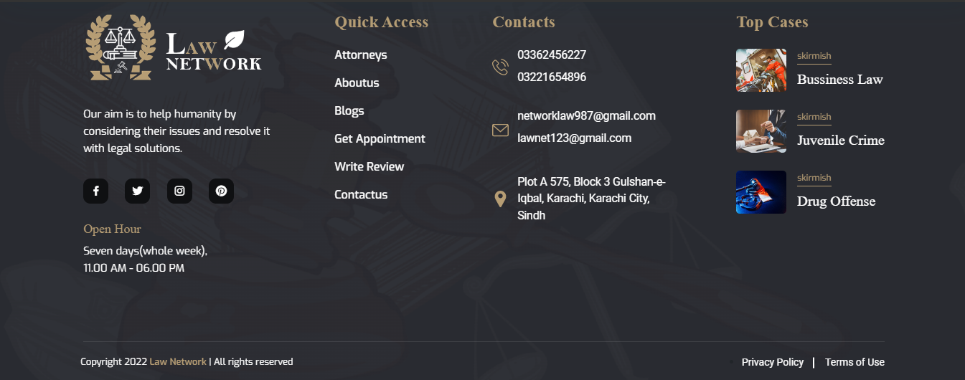



CHAPTER: 02

ABOUT US

This is the About us Page

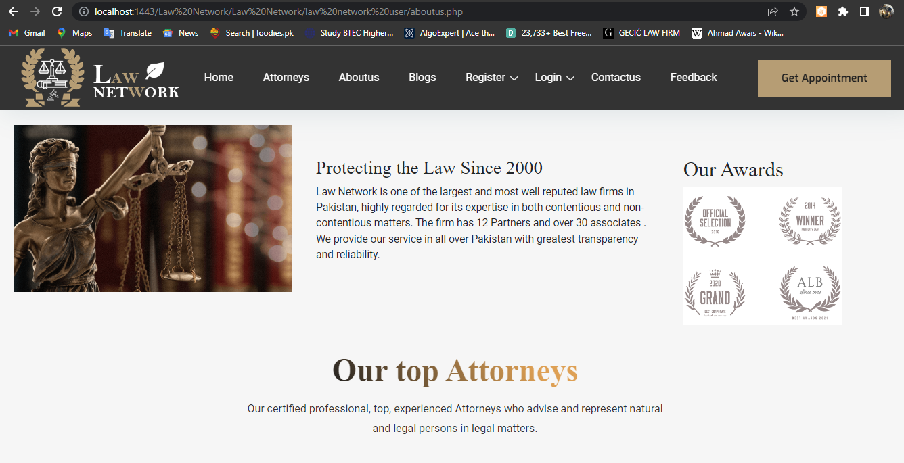

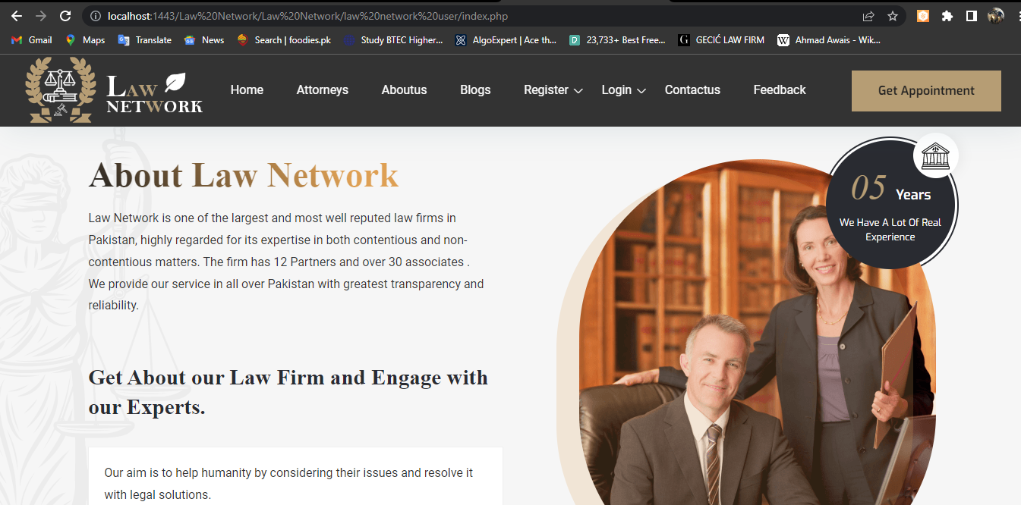



CHAPTER: 03

CONTACT US

This is the Contact us Page.

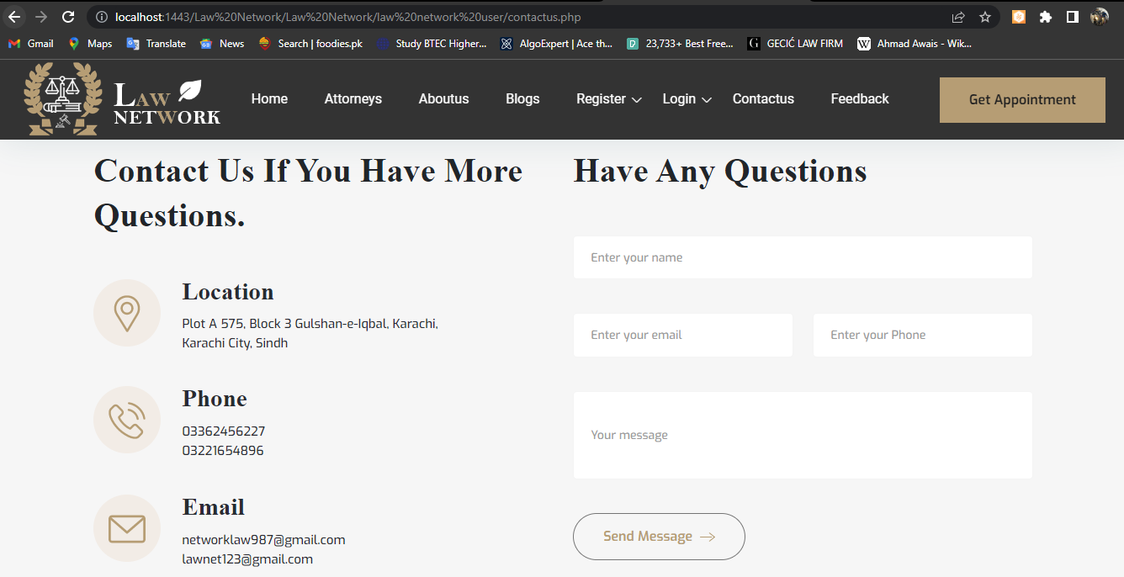



CHAPTER: 04

ATTORNEY SIGNIN

## 

This is where Attorney SignIn as a user.

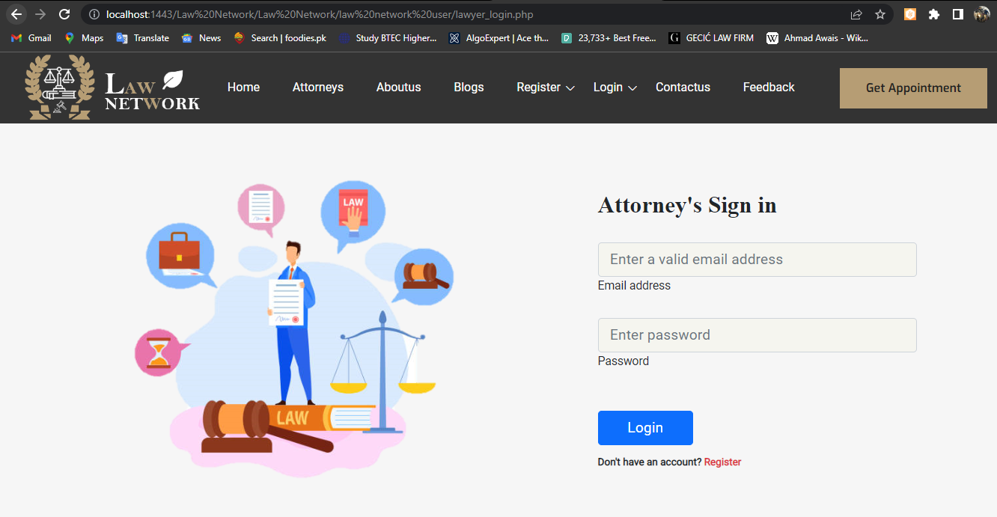



CHAPTER: 05

USER LOGIN

After Signup you will go to Userlogin where you login than book your Order.

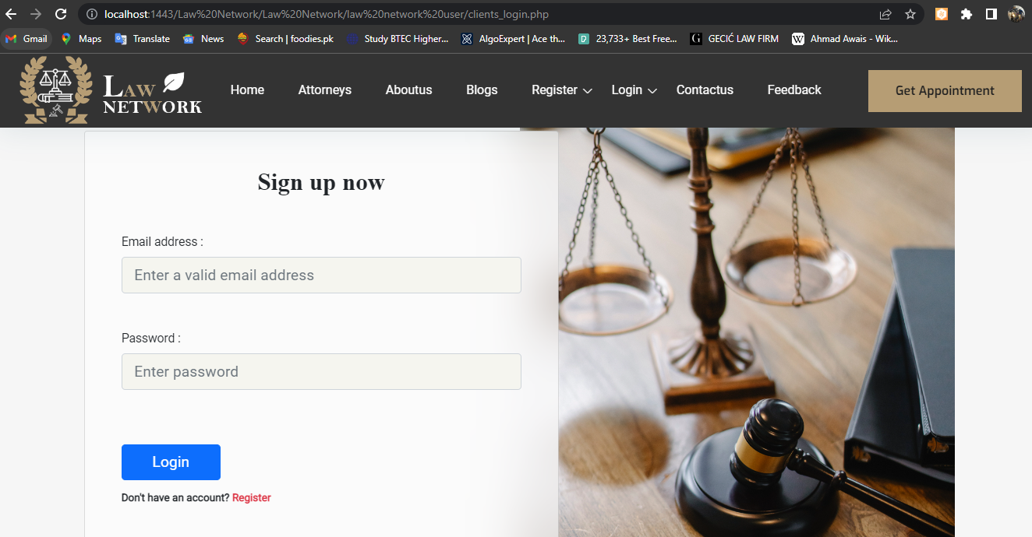

.

 CHAPTER: 06

APPOINTMENTS

This is the appointment Pages.

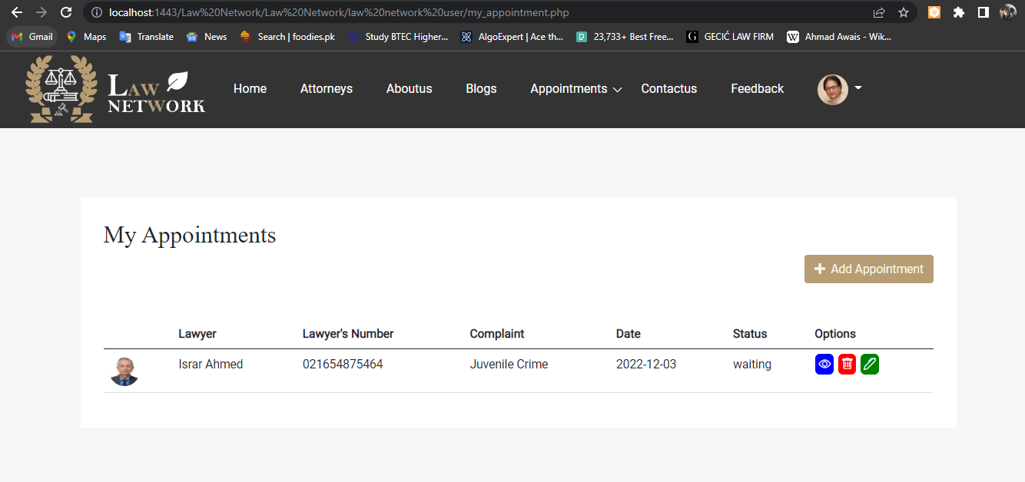

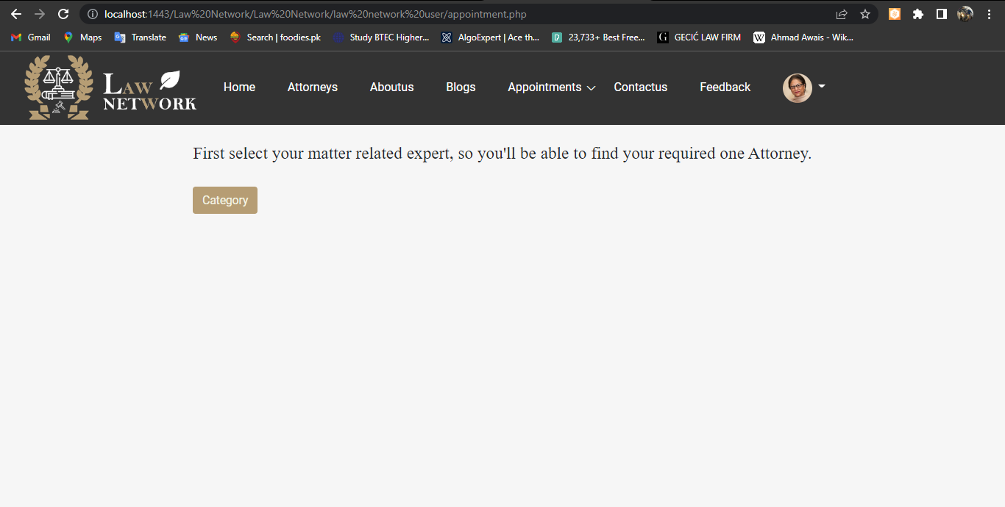

 CHAPTER: 07

DASHBOARD

This the Admin Login where the admin go into the Dashboard.

